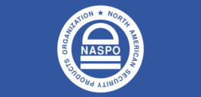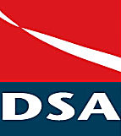

**A JOINT NORTH AMERICAN SECURITY PRODUCTS ORGANIZATION – DOCUMENT SECURITY ALLIANCE PORJECT**

## MNIMUM REQUIREMENTS FOR SECURE DOCUMENTS

A CALL FOR PARTICIPATION

In the Development of an

American National Standard for Secure Documents

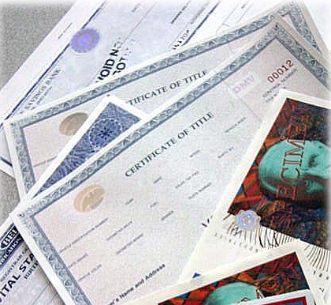

**NORTH AMERICAN SECURITY PRODUCTS ORGANIZATION, NASPO**

204 E. Street NE, Washington, DC 20002

(202) 608 1322

www.napso.info

**Contact: Michael O’Neil, NASPO Executive Director and the**

**Convener, for additional information at mikeo@naspo.info**

|  |  |
| --- | --- |
|  | **A CALL FOR PARTICIPATION IN THE DEVELOPMENT OF AN American National Standard for Secure Documents** |

**CONTENTS**

The Problem Page 3

Seeking a solution Page 4

Who should join the Security Document Project Page 4

Sponsor and Member Information Page 5

Fee structure Page 6

Membership application Page 7-8

About Page 9

**Second Meeting:**

March 14, 2012 – 9 a.m. – 3 p.m.

ANSI Headquarters

1899 L Street, NW

11th Floor

Washington, DC 20036

Contact Convener on any questions

Mike O’Neil

[mikeo@naspo.info](mailto:mikeo@naspo.info)

(612) 281-7141

Gold Sponsor

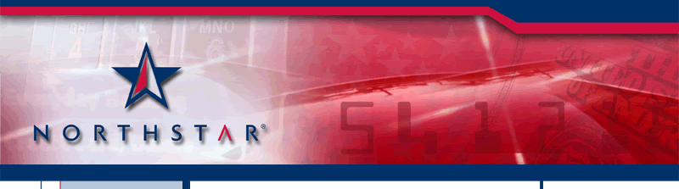

Sponsors

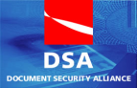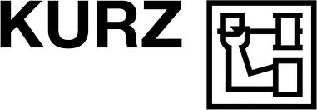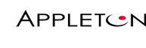

|  |  |
| --- | --- |
|  | **A CALL FOR PARTICIPATION IN THE DEVELOPMENT OF AN American National Standard for Secure Documents** |

**It is the intent of NASPO, an ANSI Accredited Standards Developer, to create an American National Standard to be used in the evaluation, design, production and distribution of secure documents.**

**THE PROBLEM:**

The establishment of trust for a document is built upon a knowledge the document has been created and produced using specialized technology and knowledge to prevent or reduce the opportunity of fraud. The processes and procedures within this standard will establish trust between the producers and users.

The following issues have created significant flaws in many government and business transactions:

* Many currently used documents in the United States are subject to counterfeiting and false issuance.
* Authentic, properly issued documents may not provide any security features that promote easy validation for field authentication.
* At present many businesses, employers, banks, insurance companies, educational institutions etc. are required to accept documents that have no valid method of authenticating either the document or the data resident upon that document.
* These deficiencies in the ability to authenticate and verify the documents put relying organizations and government agencies at risk.

Rapid development in digital technology, computers, desktop scanners, image manipulation software and inexpensive printers has made it possible for someone with minimal skill to create and proffer counterfeit documents whose falsity is undetectable.

The presentation of counterfeit academic transcripts, diplomas and licenses leads to unqualified persons being employed beyond their skill levels. The poor performance of these employees results in a threat to the consuming public and issuing authorities.

Counterfeit Certificates of Compliance accompanying parts shipment supports the introduction of faulty or sub-standard counterfeit parts into the manufacture of critical systems. This can cause system failure and the possibility of significant damage and/or the deaths of innocent people.

The acceptance of counterfeit identity documents by financial institutions, corporations and government agencies creates an environment where an institution can be subject to citations and financial penalties by regulators for compliance failure.

The Document Security Alliance highlighted the following areas of fraud in its ***Report to the Nation***  ([www.documentsecurityalliance.com](http://www.documentsecurityalliance.com))

* Identity
* Bank account
* Real Estate
* Valuable Item Appraisal
* Educational achievement records, transcripts
* Prescription
* Medicaid/Medicare claims
* Motor Vehicle Title
* Professional License
* Certificates of Notarization
* Court Orders
* Certifications
* Insurance claims
* Certificate of Compliance
* Customs and Immigration

|  |  |
| --- | --- |
|  | **A CALL FOR PARTICIPATION IN THE DEVELOPMENT OF AN American National Standard for Secure Documents** |

**SEEKING A SOLUTION**

The need for this standard evolved from The Document Security Alliance ***Report to the Nation.***

This document highlighted a few of the most significant problems facing America because of the lack of a cohesive and comprehensive understanding of the need for certain type of documents to contain security features that prohibit creation of false replications of these documents.

Although certain segments of the document sector rely on organizational Best Practices, a formal, and thorough standard does not exist for secure documents. All “Best Practices” policies are basic guidance to help the specific industry sector gain some control over its documents. Because “Best Practices” are typically not created using the expert consensus process of ANSI, they fall short of being technically balanced or nationally recognized.

**An American National Standard**

There exists a need for a national standard; currently there is no nationally recognized standard for theevaluation, design, production and distribution of secure documents. The practice of assuming a document is valid because it has the “look and feel” of a valid document allows for the opportunity of fraud to be accomplished. This assumption creates a risk for our society, economy and nation.

**Design Concepts and Procedures**

The creation of this Secure Document Standard will establish the best practices and procedures which will allow relying parties to have a substantially higher level of confidence that they are issuing or accepting a credible document.

**Who should join the Secure Document project?**

Any business, organization or government agency that produces, uses, issues or relies upon secure documents for transactions, validation of achievement, proof of insurance, proof of title, proof of origin, compliance with specifications, etc.

**Identified interest groups:**

Identity Adjudicators

Custodians of Identity Information

Issuing Authorities

Enrollment Authorities

Relying Parties

Citizen and Citizen Advocacy Groups

Academia

Special Interest Groups

Anti-Fraud Groups

Law Enforcement

Evidence Providers

General Interest

Security component suppliers

|  |  |
| --- | --- |
|  | **A CALL FOR PARTICIPATION IN THE DEVELOPMENT OF AN American National Standard for Secure Documents** |

**SPONSOR AND MEMBERSHIP INFORMATION**

The formation of the NASPO/DSA Security Document project must originate under the ANSI established criterion for membership and participation. Members on the Security Document standard development project are expected to participate fully by their attendance at meetings, voting, exchange of correspondence, financial and other obligations that may be appropriate. The rules of standard writing, under the ANSI umbrella, is a consensus process and NASPO will seek to have a balance of interest among the participants without the dominance of a single interest group or philosophy.

Sponsorship will recognize organizations that have a significant economic or social commitment to the prevention of fraud through the spread of counterfeit documents. These organizations, through their support, will be acknowledged as leaders in the fight against the fraudulent acts perpetrated by individuals and organization that prey upon our society.

The NASPO Chairman and Security Document Standard Convenor will review all applications as to relevant interest and make recommendations accordingly.

**The Security Document project may be limited in membership number based upon the reasonable ability to manage the interested parties group.**

|  |  |  |
| --- | --- | --- |
| **Benefits** | **Platinum**  ***$20,000.00*** | **Gold**  ***$10,000.00*** |
| **Active Participating Member** | Yes | Yes |
| **Voting** | Yes | Yes |
| **Name & Logo in All Publications** | Yes | Yes |
| **Name in All Press Releases** | Yes | Yes |
| **Name & Logo on all meeting materials** | Yes | Yes |
| **Name & Logo Featured on NASPO website** | Yes | Yes |
| **Promote participation in the Standard process in company announcements or advertisements** | Yes | Yes |
| **Number of people to attend meeting (only 1 vote)** | 2 | 1 |
|  |  |  |

**NASPO and DSA Members**

Members should have a strong interest in the development of a national Security Document Standard. They must also be aware that there is international interest in this area.

The development of this standard will establish a set of best practices and provide a significant level of guidance for many industries and organizations. While the final outcome of the process is unknown, it is not unreasonable to think the standard will allow new revenue opportunities to be created.

Participation on the Secure Document Standard development project will allow members to directly express their interest and opinions into this standard through active participation and the comment process.

|  |  |
| --- | --- |
|  | **A CALL FOR PARTICIPATION IN THE DEVELOPMENT OF AN American National Standard for Secure Documents** |

**NASPO-DSA Secure Document Project Participation Fees**

Fees are being established to support the administration of the project to cover administrative costs, meeting expenses and administrative travel expenses. They are established in an effort to support the activities of the project without undue financial barriers to participation.

**MEMBERSHIP FEE STRUCTURE**

|  |  |
| --- | --- |
| **Members category:** | **Annual Fee** |
| Over $500 Million in security products revenues | $7,000.00 |
| Under $500 Million in security products revenues | $5,000.00 |
| Trade Association | $4,000.00 |
| Non-profit Organization — not representing ANY industry | $3,000.00 |
| Non US Based Observers (non-voting status) | $2,000.00 |
| General Interest (non-user or product) | $500.00 |
| US Government, State, Federal, Regional Authority | $500.00 |
| Academia | $500.00 |
| Law Enforcement | $250.00 |

**A 10% discount will be given for members of either NASPO or DSA.**

**This is not cumulative if you are members of both organizations**

**MEMBERSHIP APPLICATION**

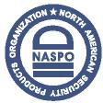

1. **Please provide the following information for the primary member:**

|  |  |
| --- | --- |
| **Prefix –** Dr., Mr., Mrs., Ms., |  |
| **Individual’s Name** |  |
| **Company/Organization/Entity** |  |
| **Telephone No.** |  |
| **Mobile No.** |  |
| **Email Address** |  |
| **Address**  **Number & Street**  **Suite No**  **City**  **State / Province**  **Country**  **Zip Code** |  |
|  |  |

1. **Please select an Interest Category that reflects the interest represented by your participation.**

* **Sponsorship**
* **Corporate**
* **Trade Association**
* **Non-profit Organization**
* **General Interest**
* **Government**
* **Academia**
* **Law Enforcement**

**Statement of Interest**

Please provide a brief statement of interest in support of your participation and/or sponsorship of the NASPO/ DSA Standards Committee.

***Please mail your***

***Application with your check or PO to:***

**NASPO Treasurer**

**204 E Street NE**

**Washington, DC 20002**

**Membership Application**



Alternate Representative

**If you have expressed an interest in a membership and wish to provide an**

**Alternate Representative, please provide the following information.**

|  |  |
| --- | --- |
| **Prefix –** Dr., Mr., Mrs., Ms., |  |
| **Individual’s Name** |  |
| **Company/Organization/Entity** |  |
| **Telephone No.** |  |
| **Mobile No.** |  |
| **Email Address** |  |
| **Address**  **Number & Street**  **Suite No**  **City**  **State / Province**  **Country**  **Zip Code** |  |
|  |  |

**Please Remit Applications to:** I enclose payment using:

1. Company Purchase Order #

Or

1. Check enclosed totaling (U.S.) $

Payable to: North American Security Products Organization (NASPO).

***Please mail your***

***Application with your check or PO to:***

**NASPO Treasurer**

**204 E Street NE**

**Washington, DC 20002**

|  |  |
| --- | --- |
|  | **About** |

**The American National Standards Institute, ANSI**

As the voice of the U.S. standards and conformity assessment system, the American National Standards Institute (ANSI) empowers its members and constituents to strengthen the U.S. marketplace position in the global economy while helping to assure the safety and health of consumers and the protection of the environment.

The Institute oversees the creation, promulgation and use of thousands of norms and guidelines that directly impact businesses in nearly every sector: from acoustical devices to construction equipment, from dairy and livestock production to energy distribution, and many more. ANSI is also actively engaged in accrediting programs that assess conformance to standards — including globally-recognized cross-sector programs such as the ISO 9000 (quality) and ISO 14000 (environmental) management systems.

**For more information about ANSI visit** [**www.ansi.org**](http://www.ansi.org)**.**

**The North American Security Products Organization, NASPO**

**NASPO** is an **ANSI**-accredited Standards Development Organization (SDO) based in Washington, D.C. Its members include Fortune 500 companies, commercial, industrial, government and non-governmental organizations (NGOs). NASPO maintains the ANSI/NASPO Security Assurance standard (ANSI/NASPO-SA-2008) and certifies organizations to one of three levels of security assurance. On behalf of ANSI, NASPO acts as secretariat of the International Organization for Standardization, **ISO**, Technical Committee on Fraud Countermeasures and Controls (ISO TC 247). NASPO also administers the ANSI-accredited United States Technical Advisory Group to ISO/TC 247 and ISO PC 246. NAPSO has launched a consensus body supporting the creation of an American National Standard (ANS) to define minimum requirements for proof and verification of personal identities, NASPO Identity Proofing and Verification Standard (IDP-V).

**For more information about NASPO visit** [**www.naspo.info**](http://www.naspo.info)**.**

**Document Security Alliance, DSA**

The Document Security Alliance (DSA) was created by government agencies, private industry and academia. DSA's goal is to identify methods of improving security documents and related procedures to help combat the growing acts of fraud, terrorism, illegal immigration, identity theft, and other criminal acts.

DSA members - in both government and private industry - draw upon a wide range of knowledge and detailed technical disciplines to accomplish this goal. The group is committed to develop recommendations to appropriate federal and state government agencies, private industry, and policy makers in order to improve the process and procedures surrounding document security.

**For more information about the DSA visit** [**www.documentsecurityalliance.com**](http://www.documentsecurityalliance.com)