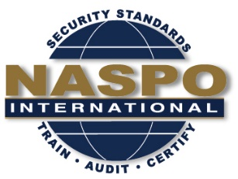

Draft Meeting Agenda
August 15 and 16, 2017
ANSI/NASPO Minimum security requirements for Birth Certificates
Marriott City Center,
30 South 7th Street
Minneapolis, MN 55402

August 15, 2017

9:00 AM Opening comments and NASPO Anti-Trust Policy Convenor
9:10 AM Introduction of members Members
9:30 AM Review of ANSI and NASPO Procedures Convenor
9:40 AM Review of Agenda Convenor
9:50 AM Review of Scope Statement Convenor
10:00 AM Review of other BC Standards Development R. Ward
10:30 AM Break
10:45 AM Introduction of Draft Standard Convenor
11:15 AM Discussion and development of Draft Standard Convenor
12:00 Noon Lunch
1:00 PM Discussion and development of Draft Standard Convenor
2:30 PM Break
2:45 PM Discussion and development of Draft Standard Convenor
4:00 PM Adjourn

August 16, 2017
9:00 AM Opening comments and NASPO Anti-Trust Policy Convenor
9:10 AM Introduction of members Members
9:20 AM Questions and comments on previous days discussions Convenor
9:40 AM Discussion and development of Draft Standard Convenor
10:30 AM Break
10:45 AM Discussion and development of Draft Standard Convenor
12:00 Noon Lunch
1:00 PM Discussion and development of Draft Standard Convenor
2:30 PM Break
2:45 PM Discussion and development of Draft Standard Convenor
3:30 PM Discussion on next meeting date and location Convenor
4:00 PM Adjourn

