NASPO INTERNATIONAL 52st Meeting
Grapevine, Texas
Gaylord Texan Resort & Convention Center, 1501 Gaylord Trail, Grapevine, TX, 76051
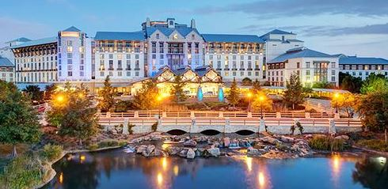
Date | Meeting | Time | Convener
March 28, 2018 | Exec. Board Meeting | 12:00 pm – 2:00 pm | Chairman
 | NASPO Business Meeting | 2:30 pm – 5:30 om | Chairman/President
 | Networking Hour / Dinner | 6:30 pm | Location TBD

Date | General Meeting | Time | Convener
March 29, 2018 | Nominations for new Board Members  New Board Member-led Committees  Security Digital Printing DSCOOP  ANSI NAPSO BIRTH CERTIFICATE UPDATE  ANSI IDPV STANDARD  ISO Standard Development Activity  Presentation of Certificates | 9:00 – 5:00 pm | Chairman
 | LUNCH | 12:30 pm

New single day format
Emphasis on Education, Standards Activity and NASPO Structure

