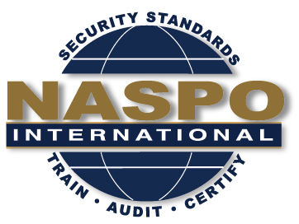
NASPO INTERNATIONAL
58th Meeting

March 25 – 26, 2020
Holiday Inn Chateau LeMoyne
301 Rue Dauphine, New Orleans, LA 70112
Rate $139.00 Group Code: NPO
Last date for rate is 1/23/20

Date | Meeting | Time | Convener
Wednesday  March 25 | NASPO BoD Meeting | 9:00 – 10:30 | Chairman
 | NASPO Exec Meeting | 10:30 – 12:00 | Chairman
 | Lunch | 12:00 – 1:00 | TBD
 | Security Mgmt Standard Revision | 1:00 – 5:00 | President
 | Evening event |  | TBD

Date | Meeting | Time | Room
Thursday  March 26 | NASPO Committee Reports  Ethics Committee  Bylaws Committee  Planning Committee  Website Committee  Auditing Committee  Business Opportunities  Birth Certificate Standard/NAPHSIS  ISO Programs Update | 8:00 – 9:30 | TBD
 | NASPO General Member Board Meeting | 9:30 – 12:30 | TBD

