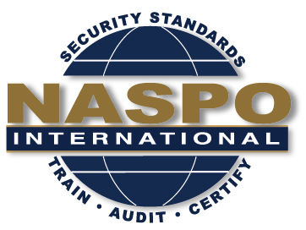
NASPO INTERNATIONAL
57th Meeting

November 13th and 14th , 2019
Embassy Suites Kansas City Plaza
220 W 43rd ST, Kansas City, MO 64111

Date | Meeting | Time | Convener
November 13 | NASPO BoD Meeting | 9:00 – 10:30 | Chairman
 | NASPO Exec Meeting | 10:30 – 12:00 | Chairman
 | Lunch | 12:00 – 1:00 | TBD
 | IDPV Training | 1:00 – 5:00 | Brian Zimmer
 | Evening event |  | TBD

Date | Meeting | Time | Room
November 14 | NASPO Committee Reports  Ethics Committee  Bylaws Committee  Planning Committee  Website Committee  Auditing Committee  Training Committee  Birth Certificate Standard/NAPHSIS  ISO Programs Update | 8:00 – 9:30 | TBD
 | NASPO General Member Board Meeting | 9:30 – 12:30 | TBD

