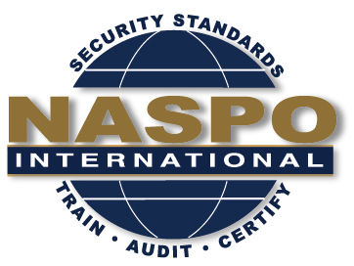
NASPO INTERNATIONAL
56th Meeting

July 23rd and 24th , 2019
July 25th 2019 Standards Committee Meeting
Crowne Plaza Northstar Minneapolis
618 Second Avenue South, Minneapolis, MN 55402

Date | Meeting | Time | Convener
July 23 | NASPO BoD Meeting | 1:30 – 3:00 | Chairman
 | NASPO Exec Meeting | 3:00 – 5:00 | Chairman

Date | Meeting | Time | Room
July 24 | NASPO Committee Meetings  Planning Committee  Bylaws Committee  ISO Committee  Training Committee | 8:30 – 12:30 | TBD
 | Lunch | 12:30 – 1:30 | TBD
 | NASPO General Member Board Meeting (including elections) | 1:30 – 5:00 | TBD

Date | Meeting | Time | Room
July 25 | NASPO Standards Committee Meeting  (included in this is the Standard Risk Management Training Course 8:30 to 12:30) | 8:30 – 5:00 | TBD

*Committee meetings will include the Ethics Committee, Event Planning Committee, IDPV Strategy Committee and the By-Laws Committee. This is subject to change based on the availability of the members.

**There is a special link or code for registration at the hotel. Please see the RSVP page on the website. Rate is available for 7/23 – 7/26.

