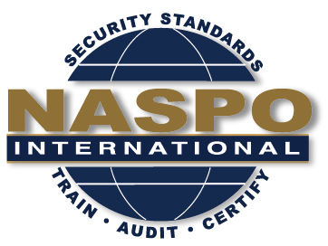
NASPO INTERNATIONAL
56th Meeting

July 23rd and 24th , 2019
July 25th 2019 Standards Committee Meeting
Crowne Plaza Northstar Minneapolis
618 Second Avenue South, Minneapolis, MN 55402

Date | Meeting | Time | Convener
July 23 | NASPO BoD Meeting | 1:30 – 3:00 | Chairman
 | NASPO Exec Meeting | 3:00 – 5:00 | Chairman

Date | Meeting | Time | Room
July 24 | NASPO Committee Reports  Ethics Committee  Bylaws Committee  Planning Committee  Website Committee  Auditing Committee  Training Committee  Birth Certificate Standard/NAPHSIS  ISO Programs Update | 8:30 – 11:30 | TBD
 | IDPV / KIDS Discussions | 11:30 – 12:30 | TBD
 | Lunch (provided) | 12:30 – 1:30 | TBD
 | NASPO General Member Board Meeting (including elections) | 1:30 – 5:00 | TBD

Date | Meeting | Time | Room
July 25 | NASPO Risk Management Training | 8:30 – 12:30 | TBD
 | Lunch (on your own) | 12:30 – 1:30 | TBD
 | NASPO Standards Committee Meeting | 1:30 – 5:00 | TBD

