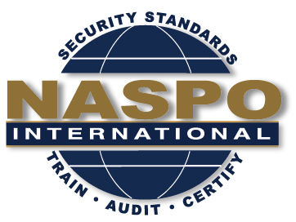
NASPO INTERNATIONAL
54th Meeting

November 5 – 6, 2018
Las Vegas Convention Center
3150 Paradise Road, Las Vegas, NV 89109

in conjunction with the Anti-Counterfeit & Currency Expo
https://www.anticounterfeit-expo.com

Date | Meeting | Time | Convener
November 5 | NASPO BoD Meeting | Noon - 1:30 | Chairman
 | NASPO Exec Meeting | 1:30 - 3:00 | Chairman
 | TBD

Date | Meeting | Time | Room
November 6 | NASPO Working Committee Meetings* | 9:00 – 12:00 | Exact times and locations are to be determined
 | Lunch | 12:00 – 1:00 | Unsponsored
 | NASPO General Meeting | 1:00 – 3:00 | Room TBD

*Committee meetings will include the Ethics Committee, Event Planning Committee, IDPV Strategy Committee and the By-Laws Committee. This is subject to change based on availability of the members.

November 7 - 8
Join NASPO at the Anti-Counterfeit and Currency Expo
Las Vegas Convention Center, Hall C1, Booth 601
https://www.anticounterfeit-expo.com

Hotel reservations are in conjunction with the expo hotel page:
https://www.anticounterfeit-expohotels.com/

